Michelle Dunaway
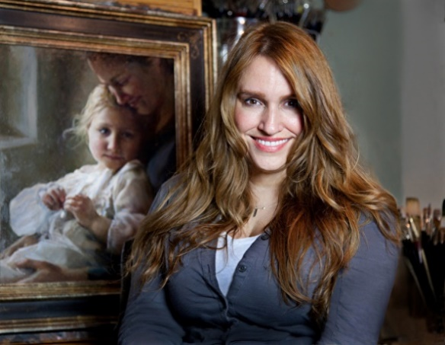
Michelle Dunaway is an American artist whose paintings are revered for their bold brushwork yet sensitive portrayal of emotions that capture the human experience. Dunaway exhibited a strong penchant for drawing the human form from a young age and that fascination has continued throughout her life and career. Her artwork has been featured in international exhibitions and publications including Fine Art Connoisseur, Art of the West, International Artist, American Art Collector, Southwest Art, and American Artist.

Dunaway’s work has received numerous awards and honors including Finalist and Award of Exceptional Merit at the 2010 Portrait Society of America’s International Portrait Competition for her painting Katie and Jenni -The Daughters of Jane Seymour; a Certificate of Excellence from the Portrait Society of America in 2014 and 2017; Finalist and Award of Exceptional Merit at the 2016 Portrait Society of America's International Portrait Competition; and Finalist in the Art Renewal Center's ARC Salon Competition. She was also a featured invited artist at the 2014 California Art Club Gold Medal Exhibition.

Although Dunaway paints and exhibits a variety of subject matter, her first love has always been portraiture. After studying anatomy and drawing at Art Center College of Design (Pasadena, CA), Dunaway continued her painting education by attending workshops with two prominent artists with whom she has become good friends over the years: Jeremy Lipking and Morgan Weistling. Both Lipking and Weistling encouraged Dunaway to pursue a career as a fine artist when they saw her work. Upon attending one of Lipking's very first workshops, Dunaway brought a painting in for the artist to critique. Lipking and his wife Danielle decided to purchase the painting for their collection. Lipking told Dunaway she was ready to be in galleries and showed the painting to the gallery where he exhibited in Beverly Hills and they subsequently invited Michelle to exhibit.

Dunaway spent time in California painting from life extensively while showing at galleries in Los Angeles and Laguna Beach and doing private portrait commissions

for local patrons. In 2009 she moved back to New Mexico, where she settled in a beautiful studio overlooking the Sandia Mountains, and was invited to show at a well-established gallery in Santa Fe. While working on paintings for gallery shows, Dunaway entered several competitions. She won the Best of Show in an online competition for her still life Mucha and Peonies and was juried into the prestigious Portrait Society of America's International Portrait Competition where her portrait painting of two sisters was chosen as one of 16 top finalists out of 1,300 worldwide entries. The painting was exhibited in Washington, DC at the Art of the Portrait Conference. Dunaway won an award for that painting and shortly thereafter received a phone call from renowned artist Richard Schmid. Schmid expressed how impressed he was by her painting ability after seeing this portrait online and invited Dunaway to paint with him and his wife, artist Nancy Guzik, at his studio in Vermont. Through their close friendship over recent years, Schmid has advised and encouraged Dunaway in her work. "Michelle is very much a force in this movement toward excellence in painting," Schmid stated recently in his instructional video wherein he painted Dunaway's portrait.

Dunaway receives invitations to give painting demonstrations, lecture, and teach internationally and these events attract artists who travel from around the world to study with her. Believing strongly in "passing on the torch" of knowledge in painting, she takes time from her busy schedule of shows and exhibitions to accept these invitations when possible. "It is extremely important to me that the legacy of strong painting continues for future generations," Dunaway states. "I have always been passionate about pursing excellence in my own work and constantly growing as an artist, and I feel a strong calling to help others reach their full potential as well. For me, creating great art is about putting light into the world. It is of course capturing the light that falls on a subject and translating that luminosity into the painting, but it's also about shining light whenever possible through teaching and passing on wisdom." After one such painting demonstration at the Portrait Society conference in 2015, Dunaway met and had a conversation with Richard Ormond, John Singer Sargent's grand-nephew. He told her something that touched her heart deeply, considering she reveres Sargent as her favorite painter. Ormond mentioned he had been in the audience and watched her main-stage painting demonstration. "I have spent most of my life concerned about preserving the legacy of Sargent's painting," he said, "but after watching you paint I am no longer worried." That was a profoundly meaningful moment for Dunaway and a great confirmation that she was spending her time wisely in teaching, volunteering, and mentoring in the arts while constantly pursuing higher levels of skill in her own painting.

Dunaway exhibits in galleries throughout the United States, and her paintings are highly sought after by sophisticated collectors. Those collectors say that Dunaway's paintings capture much more than a likeness, that her work embodies a timeless quality and illuminates the essence of the individual. Dunaway's paintings hang in private collections throughout North America and Europe. She is currently represented by these fine art galleries. InSight Gallery (Fredericksburg TX) , Legacy Gallery (Scottsdale, Az and Bozeman, MT), Sage Creek Gallery (Santa Fe NM), and Principle Gallery (Alexandria, VA and Charleston, SC)

