California art Club newsletter
Documenting California’s Traditional Arts Heritage for More Than 100 Years

Edgar Alwin Payne (1883-1947): In Pursuit of Poetic Grandeur

by Elaine Adams

ho is to say what drives the passion to create—and whether it is an environmental cause and effect, or part of one’s genetic makeup. To express oneself is arguably one of the most natural
W
human urges, although some are more eloquent than others in doing so.

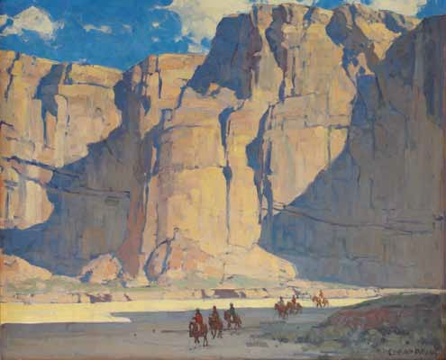
Oil on canvas 280 3 340
Canyon de Chelly
Courtesy of the Springville Museum of Art

War, he migrated westward to the Ozarks where he met and married Nancy
Ellen Reed, the daughter of Scots-Irish Appalachians. Edgar was their first son and the second of eight children. The siblings in total consisted of two sisters and six brothers. All were expected to work on the family farm and to help their father, a carpenter. These were simple people with modest means and hardworking principles.
In 1894 the family moved sixty miles southwest to Prairie Grove, Arkansas where Nancy Payne inherited property from her family. It was here that Edgar at the age of eleven first tried his hand at painting. He was inspired to copy an
oval-shaped landscape he saw painted on the back of a farm wagon. Eager to see more paintings, but with no galleries or museums in town, Payne walked ten miles to Fayetteville where he could look at the paintings on farm wagons that were lined up for sale. In his early painting attempts, his colours were made up from his father’s white lead house paint, his mother’s laundry bluing, and the toxic pokeberry weed that he smashed to make red dye. (It was known that soldiers used pokeberry juice as ink during the Civil War to write letters home.)

First Painting Jobs
In 1900 the family moved 430 miles

Life in the Ozarks
Edgar Alwin Payne was born on March 1, 1883, possibly in the rural small
town of Washburn, Missouri, somewhere near Cassville in Barry County located in the southwest part of the state near the Arkansas border. As Barry County did not record official births until 1910, the actual
location of Payne’s birth is not known. Essentially, Edgar Payne’s childhood was spent in the Ozark Mountains where he was raised as a farm boy and surrounded by the great outdoors.
Edgar Payne’s father, John Hill Payne, was a descendent of the Paynes and Herefords of Virginia. After the Civil
further south to Lovelady, Texas in Houston County, and Edgar Payne took on jobs as a sign painter. Two years later, the nineteen-year-old Payne was hired to paint local scenery for the Lovelady Town Hall and a historically significant scene depicting the battleship USS
Maine for a high school in Conroe, sixty

2

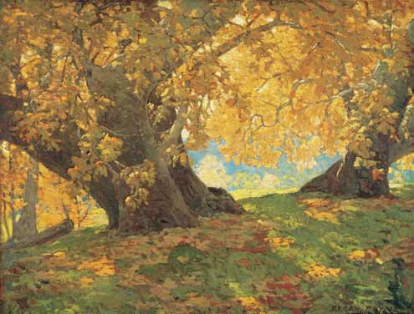miles away in the neighbouring county of Montgomery.
The 1898 explosion of the battleship Maine in Havana Harbour resulted in killing 266 sailors and triggered the Spanish-American War in support
of Cuba’s independence from Spain. The incident inspired a new sense of American patriotism and a feeling of unity, particularly in the aftermath of the Civil War that had ended thirty- three years earlier. The rallying cry became “Remember the Maine, to Hell with Spain.”

Finding His Way
John Payne couldn’t understand his son’s passion to paint, and thought it was a waste of time. Frustrated, the budding artist ran away from home at least twice, only to return to his strict father who would occasionally punish the boy. In 1902 Edgar Payne left home permanently to find his way as an artist.
While travelling through the countryside, Payne earned his living taking odds-and-ends jobs, including painting houses, signs, fences, barns, and stage sets. For a while, he travelled with a theatrical troupe and rigged their sets and painted their scenes. All along the way, these jobs provided him with real-
life experiences and hands-on training in preparation of his future art career.
In 1905 Payne moved to Houston to live with two of his sisters, Fleda and

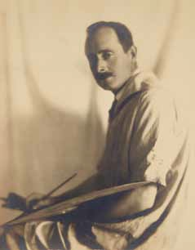
Edgar Payne, 1926
Photograph by George E. Hurrell (American, 1904-1992)
Courtesy of DeRu’s Fine Arts

Sycamore in Autumn, Orange County Park, c. 1917 Oil on board 320 3 420
Private Collection
Courtesy of The Irvine Museum

Nora. Always industrious, Payne worked as a house painter and paperhanger. In 1906 he partnered in a business venture to open the Payne-Morris Studios in Dallas that specialized in theatre scene painting.

Getting Educated
Until this point, Payne’s only formal education was up through the fifth grade and an apprenticeship in carpentry.
In art, he had no formal training, but he studied avidly from library books. Also, the jobs he took as a scene painter provided him with practical technical skills and the confidence to paint large. By using rapid and broad brushstrokes, Payne could quickly capture a scene that looked especially convincing
from a distance. The technique and style are similar in manner to that of contemporaneous illustrators and
muralists Frank Brangwyn (1867-1956)
and N.C. Wyeth (1882-1945).
On April 1, 1907 Payne enrolled in a portrait painting class at the Art Institute of Chicago, but found the training too formal and dropped out
after two weeks. For a while he thought of quitting art all together, but then

he “discovered that nature herself was the best guide and instructor…” For constructive criticism he sought the advice of Chicago artists, Ralph Clarkson (1861-1942) and Charles Francis Browne (1859-1920). Payne began to exhibit some of his small paintings at the Palette and Chisel Club and managed to sell a few.

California
In Chicago, the word was out among artists that California was rich in vast landscapes and a burgeoning art
community. Payne decided to make his first trip to California in 1909. He spent three months sketching in Laguna Beach where he met several artists, followed by a three-day visit to San Francisco.
With an introduction letter in hand from Chicago artist Gordon St. Clair (1885-?), Payne met a pretty blonde named Elsie Palmer (1884-1971). Elsie was already a successful commercial artist working for Barney and Green Outdoor Advertising for whom she designed billboards for such clients as Kellogg’s Corn Flakes, Pabst Beer, and Old Dutch Cleanser. The two went sketching together and Edgar was invited

3

to stay for dinner with the Palmer family.
Later, Elsie shared with St. Clair that she wasn’t impressed with Payne’s colour sense and found it “dull.” To which St.
Clair wrote back,“To your California bred eyes, I guess his colours are dull. He’s used to these silvery tones around Chicago. But don’t worry, he’ll get it.”

Edgar and Elsie in Chicago
With prize money Elsie Palmer won from Outdoor Advertising Companies United for designing an insignia,
she travelled to Chicago to visit her friend Gordon St. Clair. Soon, Palmer accepted a position with Cusack Outdoor Advertising for more pay than she earned in San Francisco. The following year she was given an even better position at Clague Advertising in Chicago where she worked from 1911 to 1912.
In 1911 Edgar Payne made his second trip to California, this time for an extended four months. The Los Angeles Times art critic Antony Anderson wrote in the September 17, 1911 column, Art and Artists,“at first our tremendous scale of light bothered the Chicago painter somewhat, for he was accustomed to the
mists from Michigan, but when he got his
bearings…he began to paint strong and colourful things that show he understood California scenery and southern light.” When Payne returned to Chicago he brought with him many vibrant and inspired sketches, which he exhibited and sold at the Palette and Chisel Club as well as at the Art Institute.
Payne shared his latest California paintings with Palmer. His newfound energetic and vibrant colours must

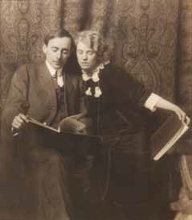
Edgar and Elsie Payne, 1913 Photographer Unknown Courtesy of DeRu’s Fine Arts


CAlIfornIA Art Club nEWslEttEr
Winter 2012
Contents

Cover Edgar Alwin Payne (1883- 1947): In Pursuit of Poetic Grandeur
by Elaine Adams
8 California Art Club Joins Forces with the Autry National Center to Present the 101st Annual Gold Medal Juried Exhibition
by Beverly Chang
10 19th-Century Academic Art and the Creative Spirit
by Michael Zakian, Ph.D.
13 J. Bond Francisco (1863-1931): The Foothills of California,
Tejon Ranch
by Deborah Solon, Ph.D.
- Membership Programs and Events
- Collectors’ Circle Corner
- Corporate 100
- Call for Entries
- Chapter News and Events
- News Briefs
- Donations
- Museum/Gallery Exhibitions and Lectures
30 Membership News
30 In Memoriam
- Book Review
- New Members

Advertisers
14 Fine Art Connoisseur Magazine
30 Plein Air Magazine
30 Heritage Auctions
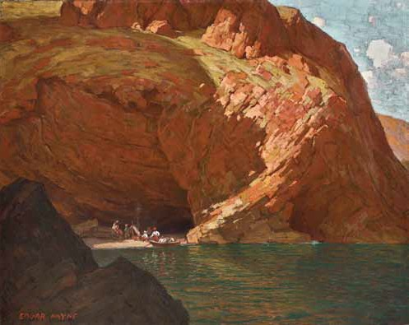
The Rendezvous (Santa Cruz Island, CA), 1915 Oil on canvas 330 3 420
Private Collection

4

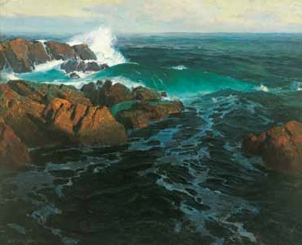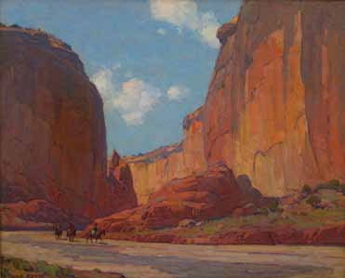

Eternal Surge, c. 1920
Oil on canvas 340 3 540 Collection of Laguna Art Museum
Museum Purchase with funds from prior gift of Louis Outerbridge
Canyon de Chelly at Sunset, 1916 Oil on canvas 260 3 320
Provenance: Atchison, Topeka and Santa Fe Railroad Collection of Leland Stanford Mansion Museum

have intrigued Palmer, as a romance was sparked and the two began dating regularly. It is noted that on one of their dates, they went out for a chop suey dinner and two western movies. Payne was enamoured by the west, and revelled in watching western movies for inspirational painting material. In one of the sets he had painted for a western play, it is recounted that each time the curtains rose to expose the scenery,
the Chicago audience enthusiastically applauded.

Getting Married
Edgar Payne and Elsie Palmer planned to wed on the morning of November 9, 1912. However, there was a slight delay. Payne was under pressure to finish a scenic backdrop for Mandel’s Department Store and the deadline was looming. Apparently, the light that morning was perfect for painting, and so the groom asked the bride
if the wedding could be postponed until the evening. Being an artist who worked under deadlines herself, Palmer supportively complied.
With the project at Mandel’s not yet complete, the couple spent their first day of marriage working together on the backdrop to meet the deadline. When
Elsie became exhausted she fell asleep on one of the department store bed displays,

while Edgar persevered with painting.
The newlyweds took up residence in the Tree Studio Building located at 4 East Ohio Street in Chicago. The building was a complex of art studios
built by art patrons Judge and Mrs. Tree expressly to provide pleasant living and working conditions for artists. Although finances were at times sparse for the Paynes, good fortune began to come their way. At the Palette and Chisel Club Edgar won his first prize for a landscape titled Tingel Tangel on January 14, 1913 and two months later his California paintings sold out. Then, on January 12, 1914 their daughter Evelyn was born.

Back to California
In the summer of 1915 the Paynes went to San Francisco to visit the Palmer
family and to attend the Panama-Pacific International Exposition where some of Edgar’s paintings were being shown. (One of his paintings, Infinitude, sold from the Exposition.) Afterwards, they headed south to Santa Barbara where they rented a small cottage for the rest of the summer and painted in the area.
On one of their painting escapades, the Paynes arranged to sail to nearby Santa Cruz Island along with several companions and a rented pirate costume that they took turns wearing. Payne photographed various poses of the

“pirate” to include in some buccaneer paintings he wanted to develop. The trip became a further adventure when a massive storm left them stranded for an additional week with an eighteen-
month-old infant, a leaky tent, and only lima beans to eat.

Lure of the Southwest
1916 brought Edgar Payne two more group exhibitions organized by the Palette and Chisel Club. The first included Walter Ufer (1876-1926), who would be elected to the Taos Art
Society the following year. Their group exhibition opened in Peoria, Illinois, then travelled to St. Louis, Missouri, and then to Lexington, Kentucky. The second exhibition included E. Martin Hennings (1886-1956) who would become elected to the Taos Society of Artists in 1924. It is likely that Ufer and Hennings shared stories with Payne about painting the southwest natives and landscapes.
When the Atchison, Topeka and Santa Fe Railroad propositioned Payne in 1916 to paint scenes of the Southwest—he was only too eager to
accept. The family packed up and left for Arizona and New Mexico where Payne spent four months painting the Grand Canyon, Canyon de Chelly, and the Hopi and Navajo reservations.

5

Community and Leadership
By 1917 approximately forty artists had moved to Laguna Beach, thus launching an art colony that was to become nationally-renowned. In a colourful description of life in the seaside town, Elsie Payne wrote:
“There was an interesting group down there that winter. The very serious Conrad Buff, the debonair Jack Wilkinson Smith—Elmer Wachtell [sic] of the sardonic wit… The genial William Griffith [and Frank] Cuprien the self-sufficient and picturesque. In the mainstreet was a rough wood moving picture house, an ice cream parlour, and
a bowling alley under a tent. We used to all come thereof evenings to bowl. Elmer Wachtell christened it ‘The Gilded Palace of Vice.’”
As the art community grew, Payne recognized a need for artists to organize and produce exhibitions of their works. He negotiated for the use of the old town hall as an art gallery and meeting place for artists. The first exhibition was held on July 27, 1918 and featured more than 100 paintings and sculptures. In just
three weeks, the exhibition drew 2,000 visitors.
To manage the gallery, Payne and a group of artists formed the Laguna Beach Art Association and elected Payne as the first president. The gallery held monthly exhibitions that were selected through a jury process. During this time, Payne also became involved with the Los Angeles based California Art Club, eventually serving as its president in 1926.
The Paynes moved to Los Angeles in 1921 to be near his galleries, the newly opened Stendahl Galleries at the Ambassador Hotel and the O’Hara and Livermore Gallery in Pasadena. In 1921 he also exhibited at the Los Angeles- area Southwest Museum’s first annual exhibition of paintings by California artists, in which he received first prize for Topmost Crags.
Edgar Payne’s leadership qualities were once again incited when modernism threatened to replace the time-honoured art philosophies he and fellow realist artists championed. In 1939 a Los Angeles branch of the Society for Sanity in Art was formed and Payne agreed to serve as its president.

Europe
The 1920s brought success, money, and time to travel. From the summer of 1922 to the summer of 1924, the Paynes visited France, Italy, Switzerland, and England. Payne’s attention to colour is expressed in his personal accounts describing driving along the Mediterranean, as published in the November 12, 1922 issue of the Los Angeles Times:
“I find Europe up to and beyond my expectations. …The sea is bluer than the Pacific or at least the red-tiled roofs make it appear so. The people show wonderful taste in their houses. Very seldom is a white house seen—they are all painted a warm tone, yellow
or orange, and you can imagine them against a blue-green sea. At this time of year too, the sycamores, chestnuts and grape vines are turning to autumn colours.”

Exploration of the Sierra Nevada
The first recorded expedition into the Sierra Nevada Mountains was in 1844. Led by “The Great Pathfinder,” Lt. John C. Frémont (1813-1890), and accompanied by the renowned mountaineer and frontiersman Kit

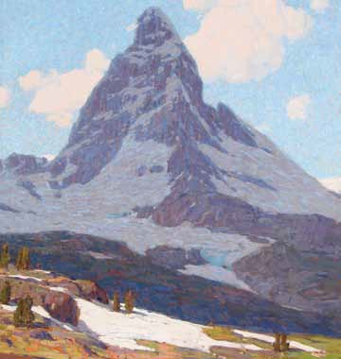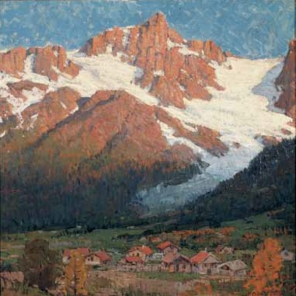

Matterhorn, Late Afternoon c. 1923 Oil on canvas 530 3 530 Collection of Harry Parashis
Peak at Argentière, c.1922 Oil on canvas 290 3 290
Courtesy of George Stern Fine Arts

6

Carson (1809-1868), together they documented many majestic Sierra sites.
In 1860 the California state legislature authorized an official exploration of the Sierra Nevada range. The California Geological Survey was initiated and the state appointed geologist Josiah Whitney (1819-1896) with the task
of organizing and leading a team of scientists through the uncharted
Sierra Nevada. The Sierra expedition resulted in several detailed published reports and topographical maps, as well as the discovery of the 14,505-foot Sierra summit, the highest peak in the continental United States, which was named “Mount Whitney,” after the state geologist.
In 1869 the celebrated conservationist and author John Muir (1838-1914) first hiked the Sierra range, and twenty-three years later he founded the Sierra Club. Construction for a high mountain route from Yosemite National Park to Kings Canyon, totalling 220 miles, began in 1915 and was named the “John Muir Trail.” Edgar Payne’s first trip to the Sierra range was as early as 1917 and he was to return many times.

The Depression Years
The 1920s brought Payne widespread popularity and financial success, however, all that was about to change with the onset of the Great Depression. Payne’s European paintings were once the focus of solo exhibitions held in Paris, New York, Chicago, and Los Angeles, but after the impact of the Stock Market Crash of 1929, Payne’s career, as with so many artists at the time, slowed dramatically. Although he continued to create full-size paintings from his plein air studies, art sales came to a lull. To help supplement their income, he and Elsie began teaching art students.

At Home in the Sierra Nevada
During a family summer camping trip to the Sierra Nevada in 1932, a quarrel occurred between father and daughter regarding strict instructions he gave her not to leave the camp. This incident triggered Elsie’s resentment toward Edgar’s authoritarian personality. Soon afterwards Elsie and Edgar separated.
Edgar Payne’s character was at times
known to be distant and reserved. In a Los Angeles Times article that appeared in February 20, 1929, editor, Fred Hogue, described Payne as “modest
in demeanour and inclined to shrink from human contact.” However, Payne discovered his alter ego in the rugged Sierra Nevada. The more he connected with the spirit of California, the more his paintings evolved into a gutsy and revolutionary expression. Whereas earlier California artists, with their European training, painted in seamlessly smooth and delicate brush, Payne applied big bold brushstrokes with generous daubs of paint in vivid colours.
As the Depression continued in the 1930s and 40s and with the onslaught of modernism, art sales plummeted. The extensive European travels were now replaced with local trips, chiefly painting in the Sierra Nevada range. Nevertheless, Payne was captivated with the scenic grandeur and compared the Sierra Mountains to the Alps:
“The rocks of the Alps are granite, of a uniform grey… In the Sierras one finds mineral ledges

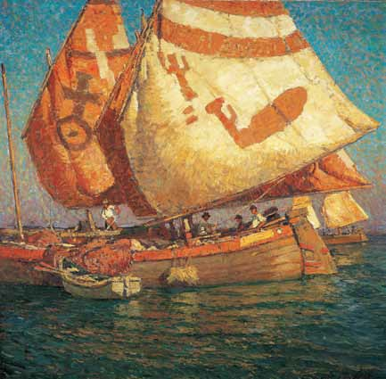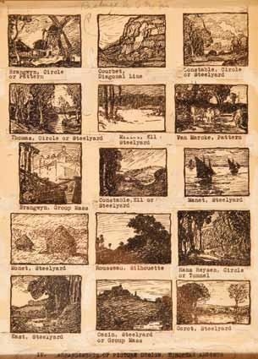

Marco Polo Relic, Adriatic (Thus Did We Sail for the Doge) [Italy], 1923-1924 Oil on canvas 420 3 420
Collection of Ruth and Robert Mirvis
“Arrangements of Picture Design, European Artists” original layout for the book Composition of Outdoor Painting by Edgar Payne (Hollywood, CA: Seward, 1914)

7

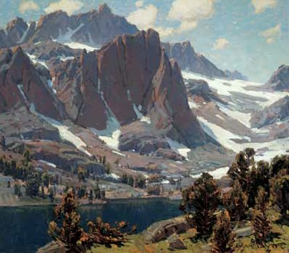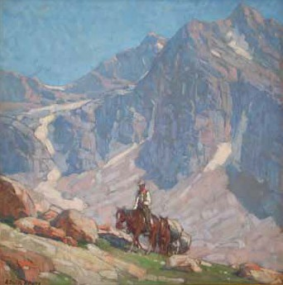

Topmost Crags, 1921
Oil on canvas 310 3 360 Private Collection
Packrider in the High Sierra, c. 1928 Oil on canvas 340 3 340
Private Collection
Courtesy of Edenhurst Gallery

everywhere. There is a diversity of colour. There are reds and greens not to be found anywhere in Europe. One finds here the mountains of Switzerland under the skies of Italy.” [Fred Hogue
quoted Edgar Payne in “God of the Mountains,” Los Angeles Times, May 22, 1927]
Payne’s passion for the eastern Sierra is expressed in a documentary film that was first screened in 1946, titled Sierra Journey. It was produced and directed by the artist with the help of his nephew, Ralph E. Payne, who was an amateur filmmaker. In the twenty-
minute 16-milimeter-colour film we see majestic views of towering glacial peaks and rocky waterfalls—and we encounter Edgar Payne alive again and hiking
into his favourite painting destination beyond Big Pine. He is dressed in a red plaid flannel lumberjack shirt, smoking his pipe and using his “view finder,” an approximately 6 x 8 inch cardboard cut- out through which he would assess his compositions.

Power in Composition
Payne was an expert photographer and occasionally used photographic references, but he did not rely on them for details
in his paintings. Instead, he discovered that by reorganizing and simplifying masses, he could alter a scene so that it had more emotional impact, resulting in an intensified and authentic experience. In preparation of painting full-sized canvases,
Payne would review his plein-air studies and rework various compositions on paper until he was satisfied.
In 1941 Edgar Payne compiled the plein air painting theories and techniques he taught his students
and published the book, Composition of Outdoor Painting. Now in its seventh edition, this straightforward
instructional book continues to inspire contemporary plein air artists.

The Legacy
While Edgar Payne led a robust lifestyle, his health at times was poor. Although he and Elsie had been separated since 1932, four years later Elsie took care
of Edgar when he became very ill. His health improved and he went back to work painting in the Sierra. Ten years

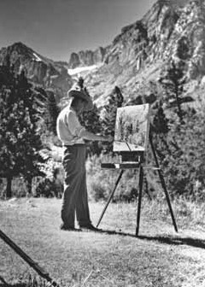
Edgar Payne painting in the High Sierra, c.1945-1946
Film still from the documentary
Sierra Journey
Courtesy of DeRu’s Fine Arts
later, in 1946, he was diagnosed with cancer. This time Elsie moved into Edgar’s Hollywood studio on Seward Street where they spent their final year together as a couple. Reportedly, it was
(Continued on page 14)

Edgar Payne
(continued from page 7)

one of their happiest years of their marriage.
Los Angeles Times editor Fred Hogue described Payne as “a poet who sings in colours,” and even Edgar Payne referred to himself as a “poet-painter.” Payne’s level of sensitivity and artistic intent are undeniably pure. His goal was to express a deeper appreciation of the world as he understood it and to emphasize the strength, poetry, and grandeur of nature. Y

Notes:
Elaine Adams is a published author and public speaker on topics relating to fine arts and aesthetics, and is Editor-in-Chief of the
California Art Club Newsletter.
Research material for this article was gathered through the following sources:
Edgar Payne: The Scenic Journey Essays by Scott A. Shields, Ph.D., Patricia Trenton, Ph.D., Lisa N. Peter, Ph.D., Peter
H. Hassrick, and Jean Stern, Published 2012 by Pomegranate Communication, Inc., Petaluma, CA; The Paynes, Edgar
& Elsie: American Artists by Dr. Rena Neumann Coen, Published in 1988 by Payne Studios Inc., (Dr. Evelyn Payne Hatcher), Minneapolis, MN; De McCall of DeRu’s Fine Arts, Bellflower, CA; Texas State Historical Association; History of Montgomery County, Texas; and A Visit with Evelyn Payne Hatcher, Daughter of Edgar and Elsie Payne, by Eric Merrell, June 2001, California Art Club Newsletter.
The exhibition, Edgar Payne: The Scenic Journey, is on view at Crocker Art Museum in Sacramento, California, February 11 – May 6, 2012; Pasadena Museum of California Art in Pasadena, California, June 3 – October 14, 2012;
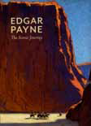and at the Gilcrease Museum in Tulsa, Oklahoma, December
1, 2012 – March
24, 2013. The 272-
page book Edgar Payne: The Scenic Journey is available in hardbound at
the aforementioned museums for $60.

Edgar Payne; The Scenic Journey

