Ferdinand Kaufmann (1864-1942)
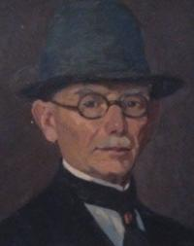
Ferdinand Kaufmann was born in Oberhausen, Germany in 1864. He moved to Pittsburgh with his family around 1881 where he resided for approximately forty years and became a member of the Pittsburgh Art Association. To advance his education, Kaufmann traveled through Europe exploring art from 1896 to 1902. While in Paris he studied at the prestigious Académie Julian under notable artists William-Adolphe Bouguereau, Jean Paul Laurens, and Benjamin Constant.

In 1921 Kaufmann relocated to Southern California and settled in Pasadena in 1934 where he exhibited with the Pasadena Art Institute. In 1939 he became an active member of the Laguna Beach Art Association. In addition to traveling around California, Kaufmann took frequent painting trips to Arizona and New England, particularly in Gloucester where he became a member of the North Shore Arts Association. Ferdinand Kaufmann passed away in 1942 in Los Angeles County.

Ferdinand Kaufmann is primarily recognized for his impressionistic landscapes and marine paintings of Southern California. Many of his subjects depict Pasadena, including the city’s architecture of charming California style red tile-roofed homes set in the landscape.

Sources: Hughes, Artists in California; Southwestern Pennsylvania Painters

Collections:
Municipal Art Gallery, Davenport, Iowa; Private Collections

Selected Exhibitions

J.J. Gillespie Gallery, Pittsburgh, 1922 (marine paintings, around Glouchester, MA); Pasadena Art Institute, 1928, 1929 (prize); Laguna Beach Art Gallery, 1930; Calif. State Fair, Sacramento, 1935, 1939 (prize); Academy of Western Painters, 1936; Golden Gate Exposition, 1939

